**TASK:**

Write a comics (visual history) to tell the potential students about Pros and Contras ot studying in BRlCS institute in funny form.

**Requirements:**

- History should consists from 10-15 (5-7 for distant students) pictures forming a story, and should fit into A3 paper format;

- History should have introduction, content and conclusion parts;

At least half of pictures should have text conversations;

- Pictures should be accurately drawn and properly colored;

- History should be fun.

**Task should be done using AGILE/SCRUM approach.**

Each important action or document should be photoed and placed to Telegram (for offline students) and to GlTHUB (for distant students) every 20 minutes.

**Timeline:**

- Initial discussion (15 minutes or less)

**Sprints:**

- 5 minutes for iteration planing.

- 10 minutes for action.

- 5 minutes for retrospectiveEvery 20 minutes you should deliver new (improved) version of the comics.

**Deadline:**90 minutes

**Preliminary discussion (within 15 minutes)**

**Goal definition:**

- Create a fun and humorous cartoon showing the pros and cons of studying at BRICS Academy.

- Make sure the comic fits in A3 paper format.

- Includes introduction, content and conclusion sections.

- At least half of the images need to have text dialogue.

- Cartoons need to be accurately drawn and properly colored.

- Interesting and engaging to potential students.

**Role Assignments:**

- Product Leader (Geng Zhijie): Make sure the comic meets all requirements.

- Scrum Master (Geng Zhijie): Track time and ensure the team follows the SCRUM process.

- Artist (GengZhi jie): Responsible for drawing and coloring comics.

- Screenwriter (GengZhi jie): Responsible for creating storyline and dialogue.

- Reviewer (GengZhi jie): Responsible for reviewing work and providing feedback.

**Tools and communication:**

Share progress using Telegram (offline students) and GitHub (remote students);

Use digital drawing tools (e.g. Photoshop, Illustrator) or traditional drawing materials (e.g. preferred);

-------------------------------------------------------------------------------------------------------

**Sprint 1: Introduction**

- Planning (5 minutes)

- Define scenarios and conversations:

Scenario 1: A student is at home wondering whether to study at BRICS Academy.

Scenario 2: Student discusses BRICS Academy with family or friends.

Scenario 3: A student decides to visit BRICS College.

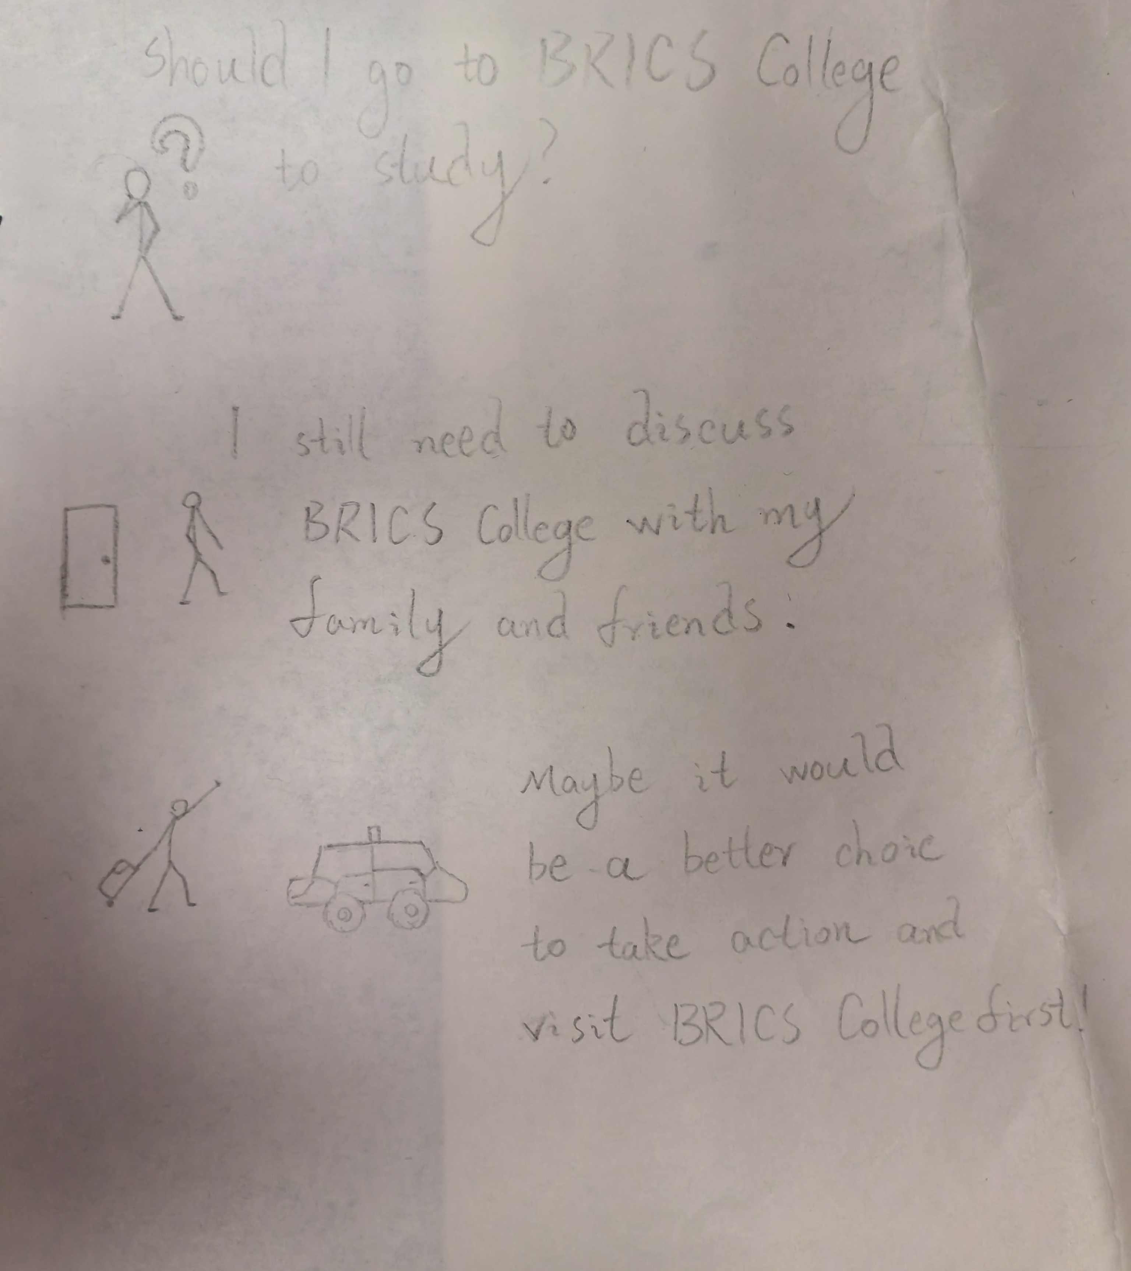

***Action: Part One/ Part Two/ Part Three***

**Sprint 2: Content**

- Planning (5 minutes)

- Define the scene and dialogue:

Scene 4: Students arrive at BRICS College and see the beautiful campus.

Scene 5: Students visit the classroom and see high-tech equipment.

Scene 6: Students communicate with current students to understand study pressure.

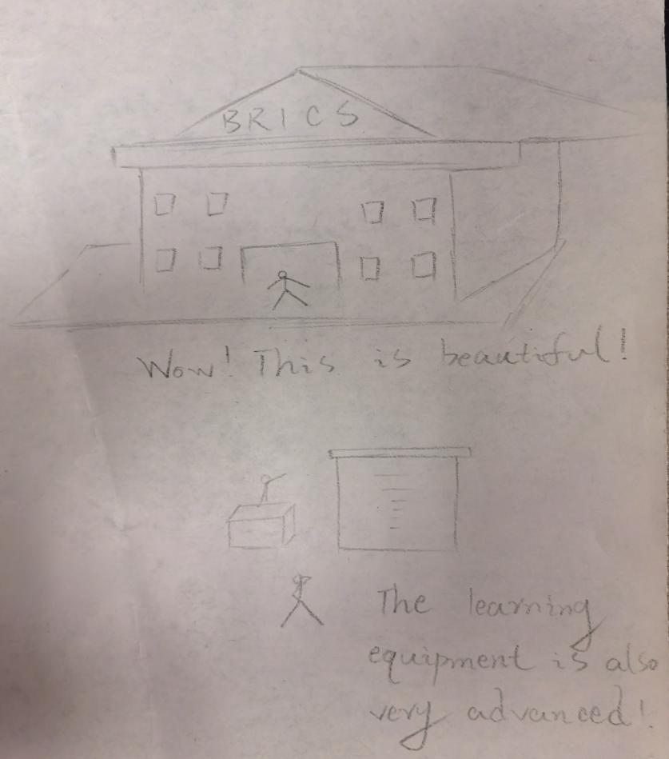

***Action: Part Four/ Part Five***

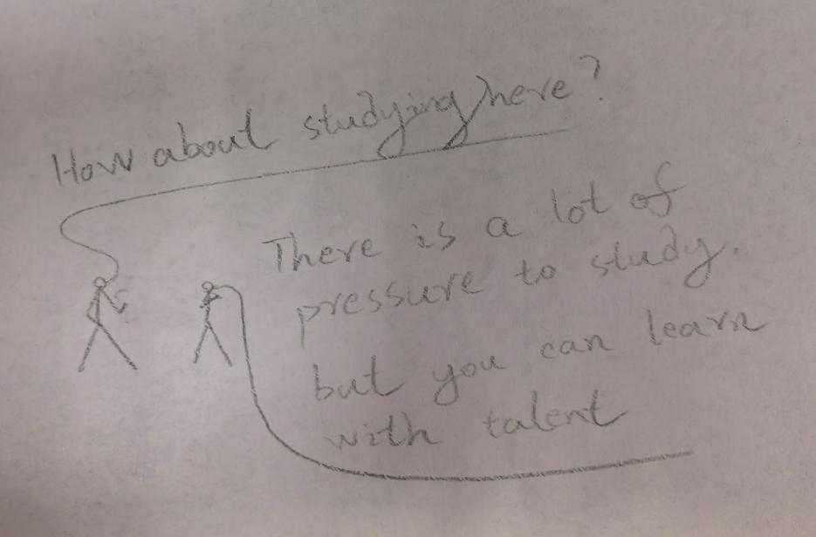

***Action: Part Six***

**Sprint 3: Conclusion**

- Planning (5 minutes)

- Define the scenario and dialogue:

Scenario 7: Students summarize the pros and cons.

Scenario 8: Students make a decision.

Scenario 9: Students are happily preparing to enter school.

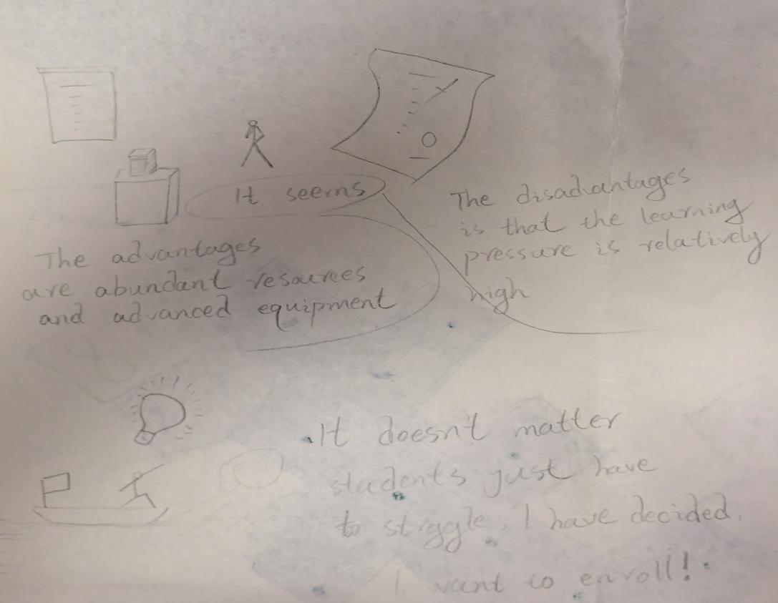

***Action: Part Seven/ Part Eighty***

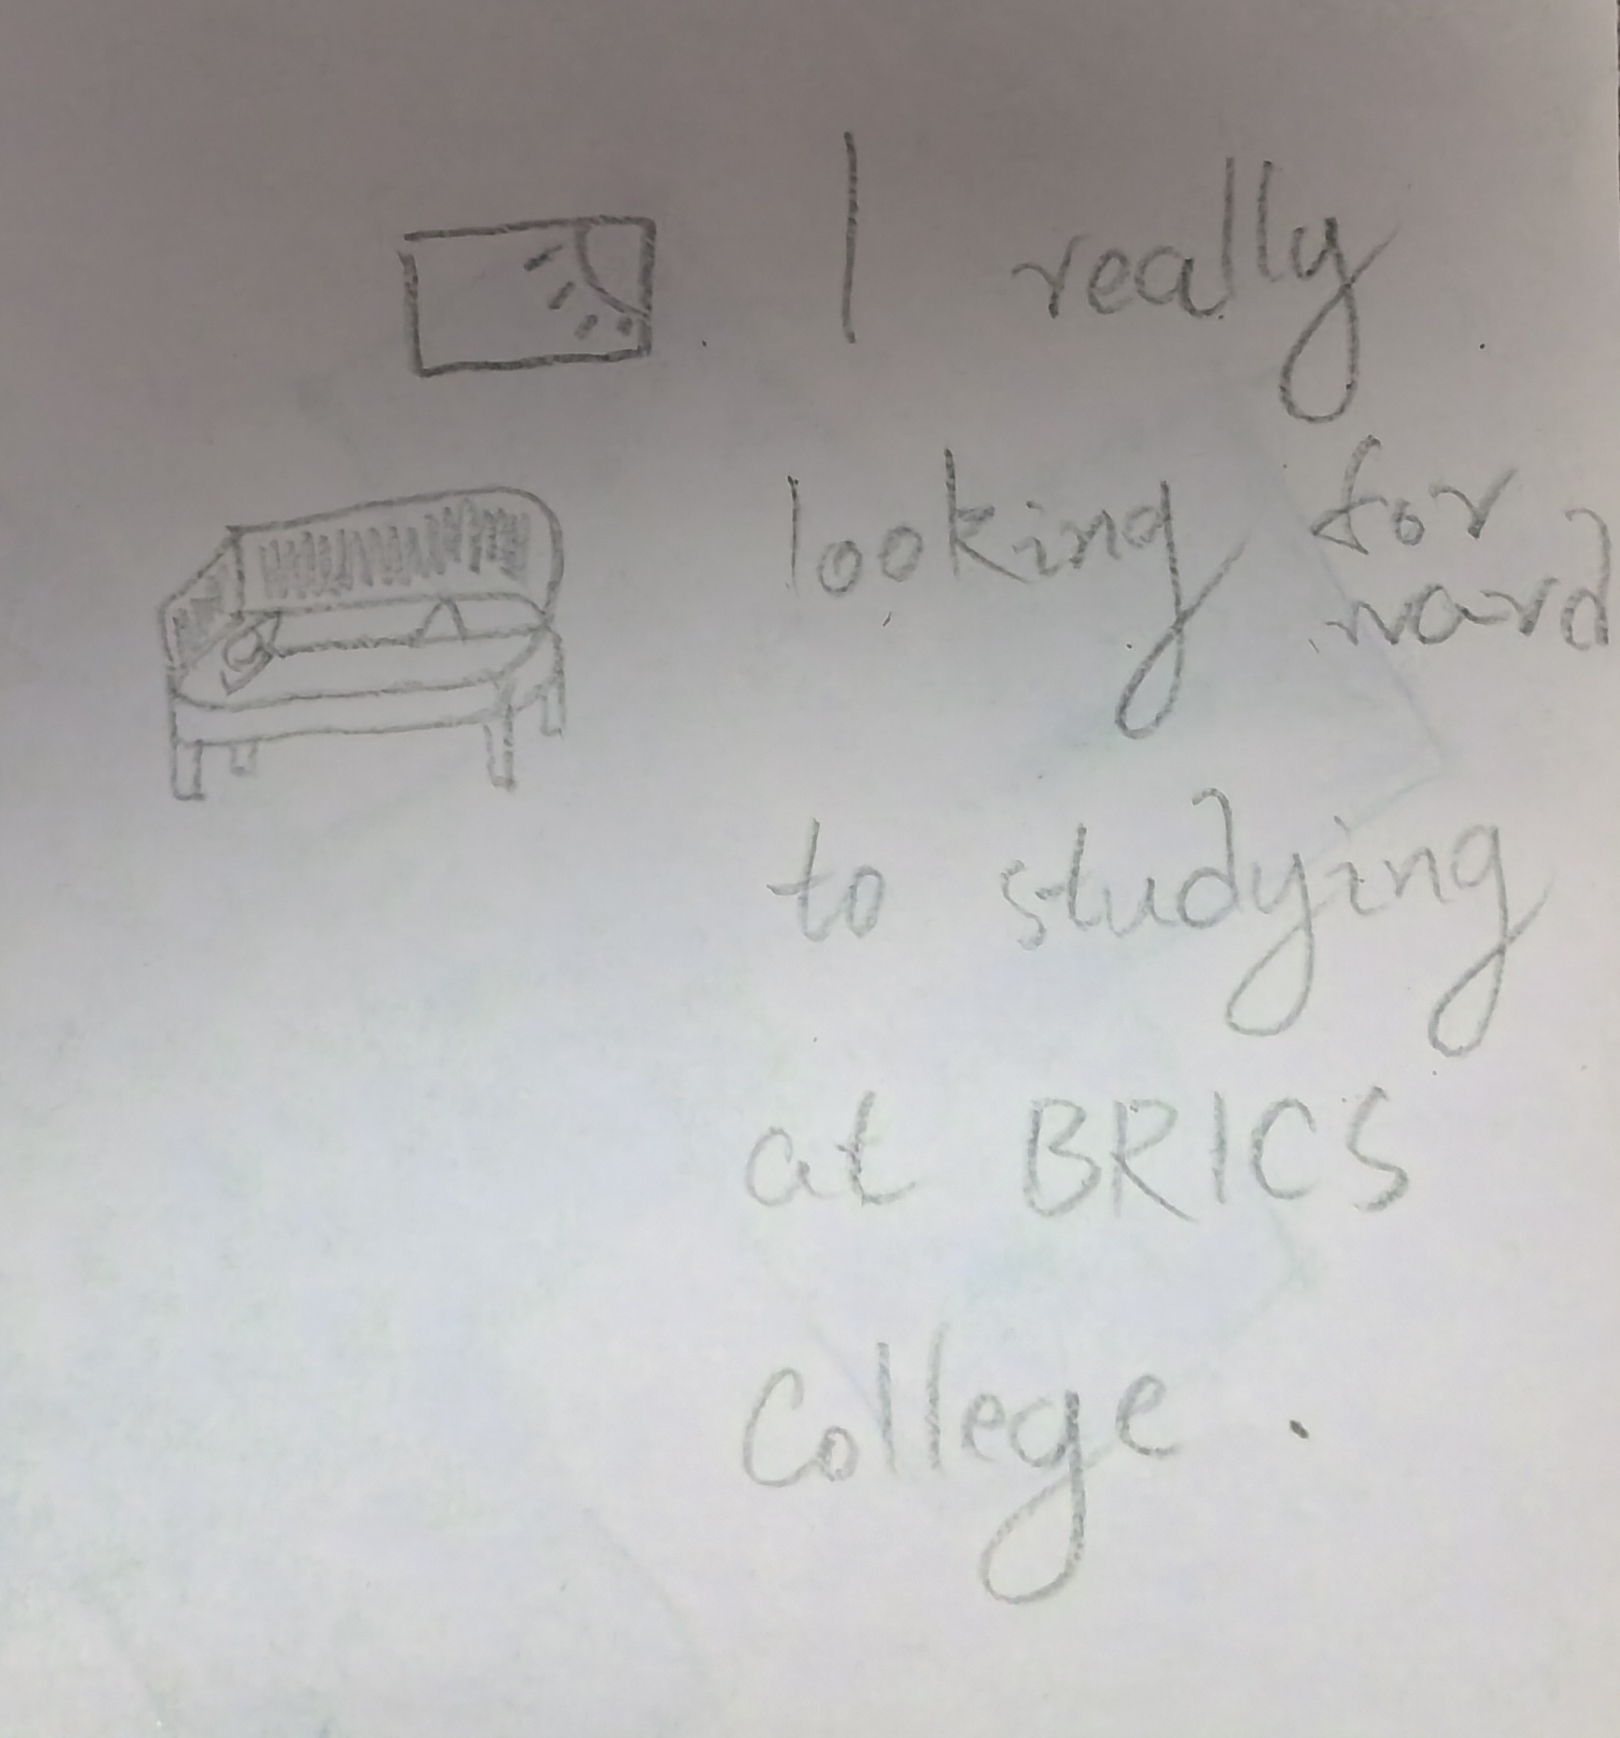

***Action: Part Nine***

**Sprint 4: Review and refine**

- Planning (5 minutes)

1). Plan to review and polish the entire comic.

2). Assign tasks to artists and screenwriters.

- Action (10 minutes)

Screenwriters and artists - perfect sketches and dialogue to ensure a coherent and interesting story.

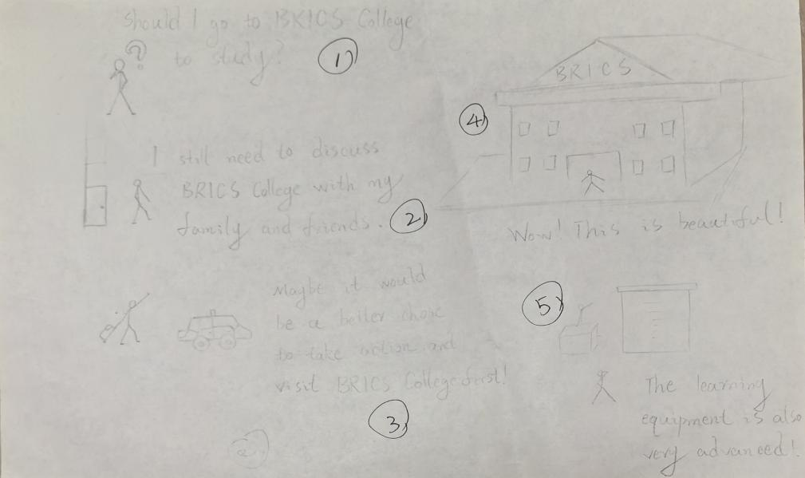

↓



↓

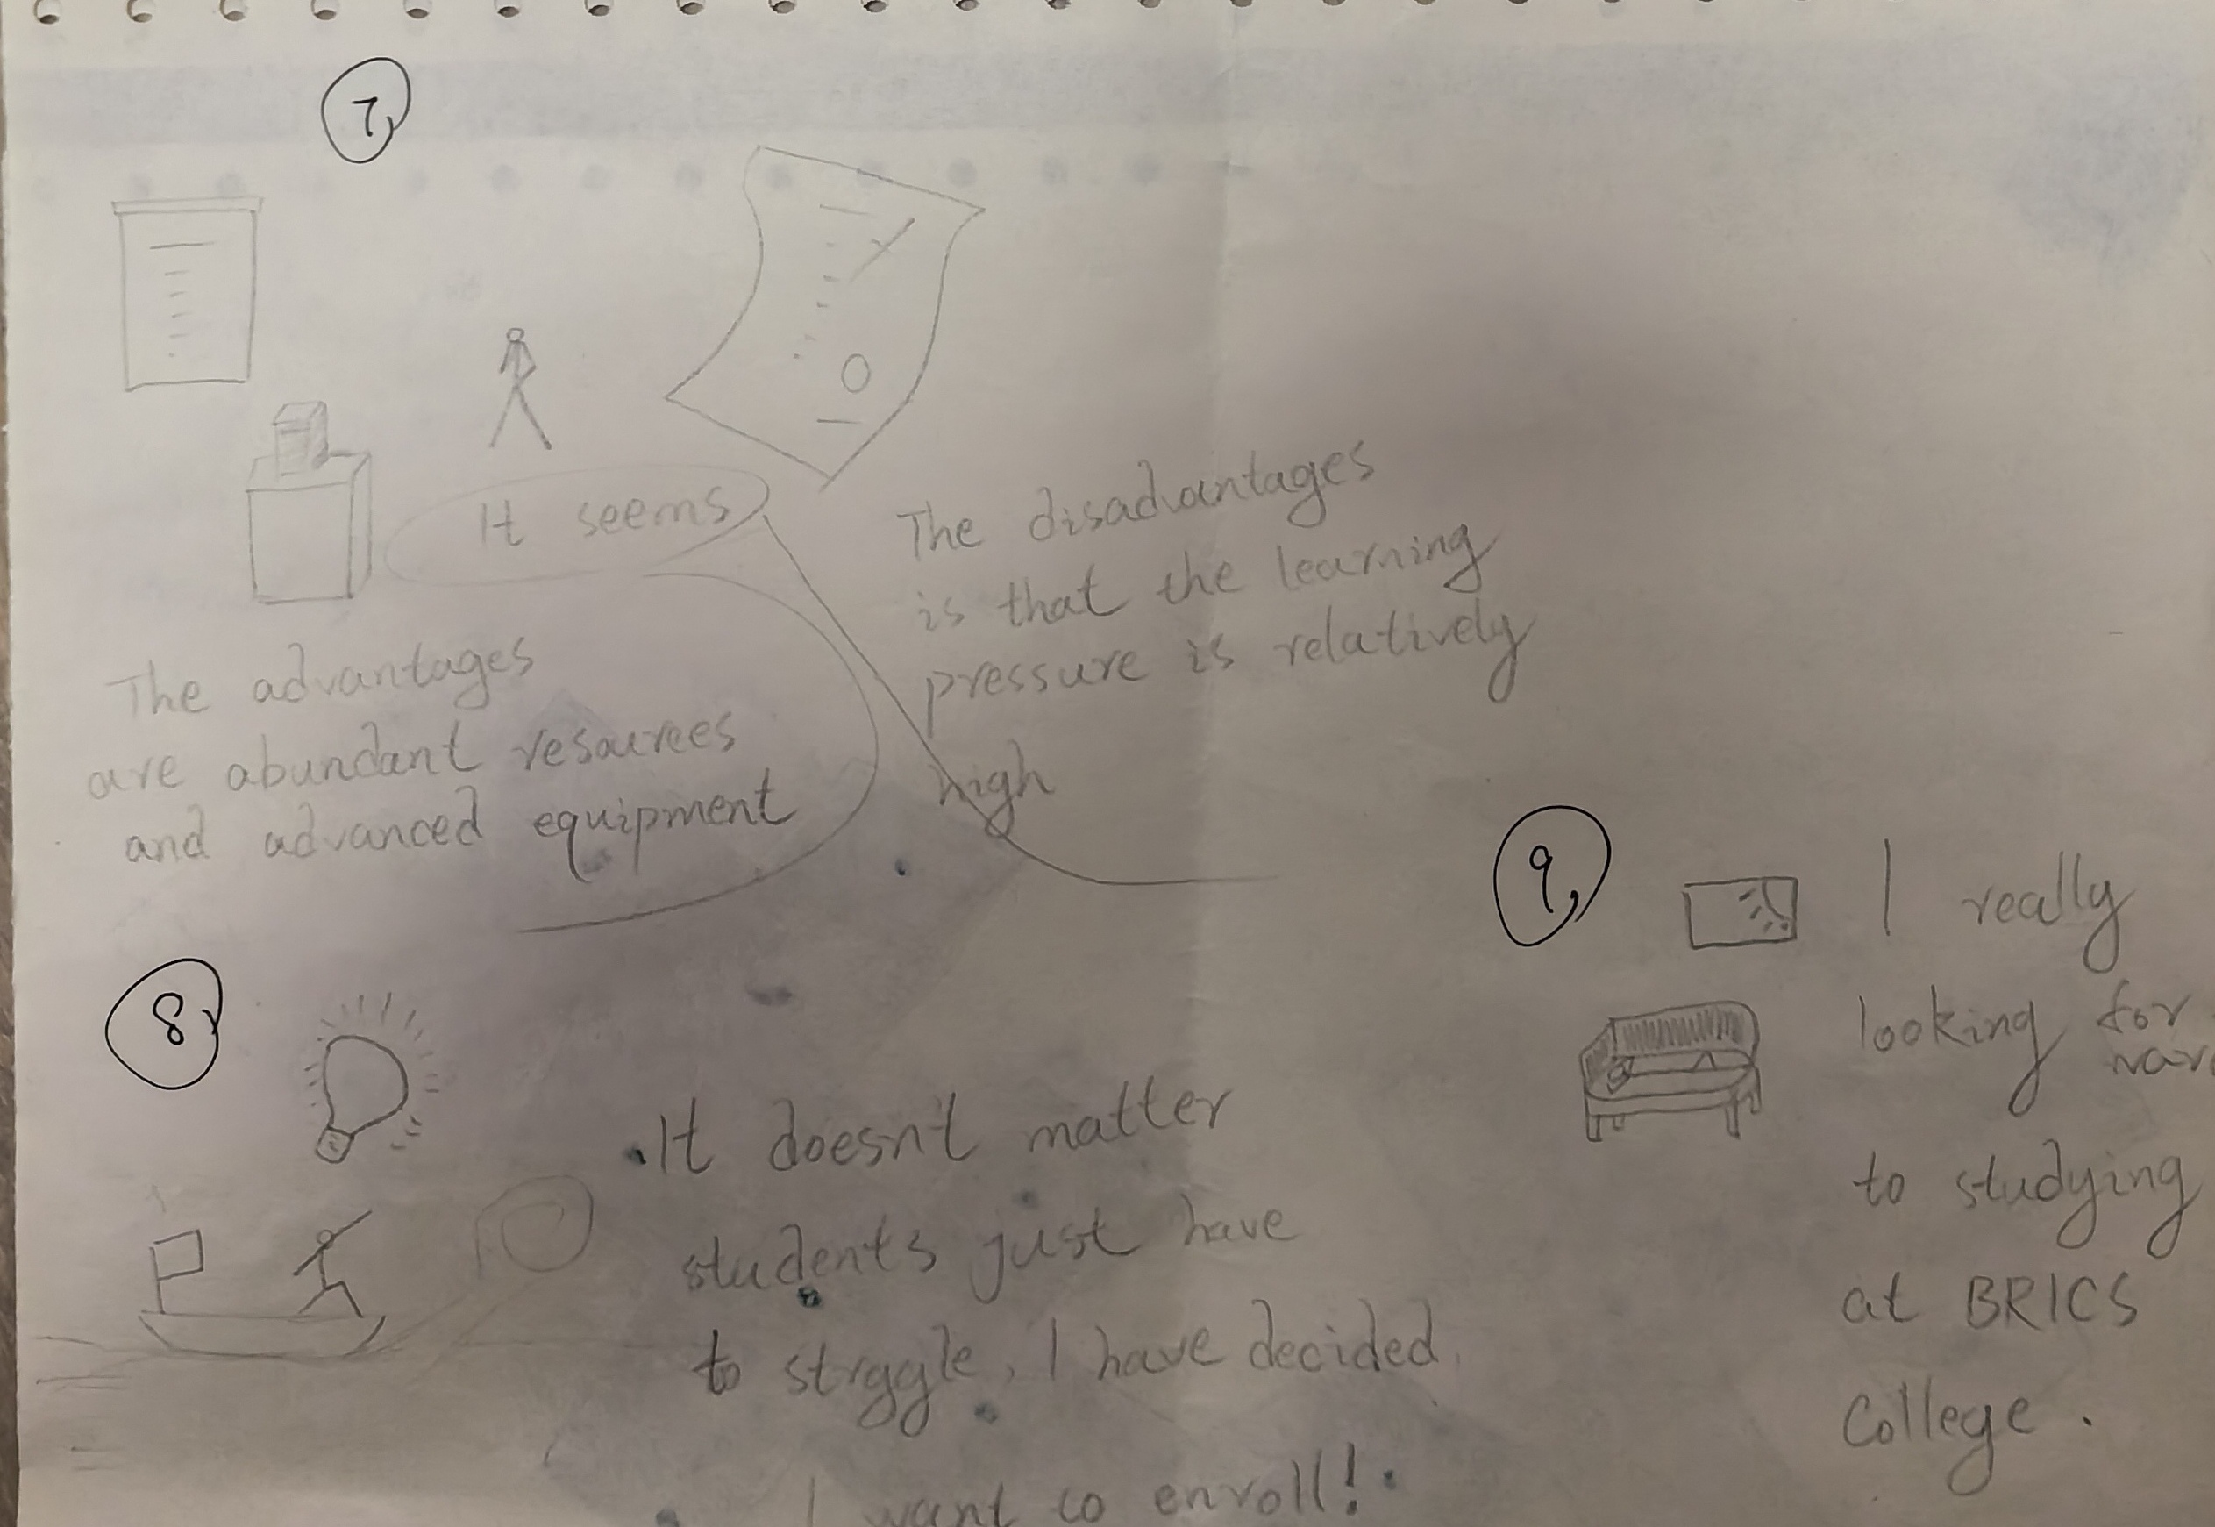

***Action: All Parts***

**Sprint 5: Final touches and coloring**

- Planning (5 minutes)

1). Plan the final touches and coloring.

2). Assign tasks to painters.

- Action (10 minutes)

Artist - Colors the comic and adds final details.

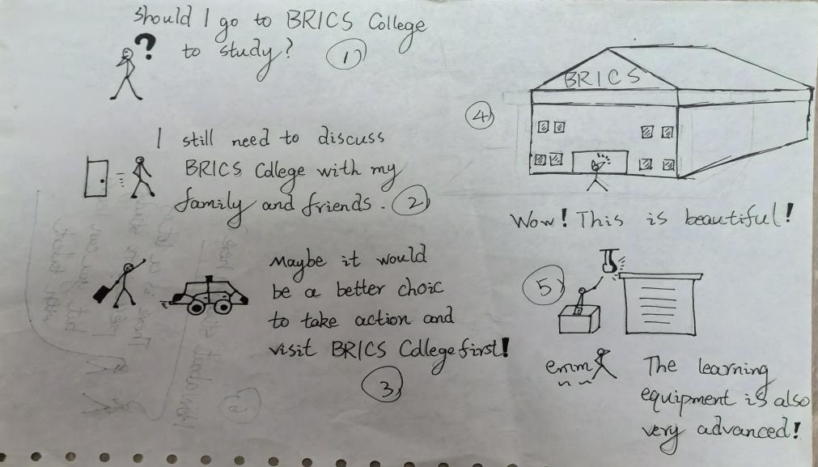

↓

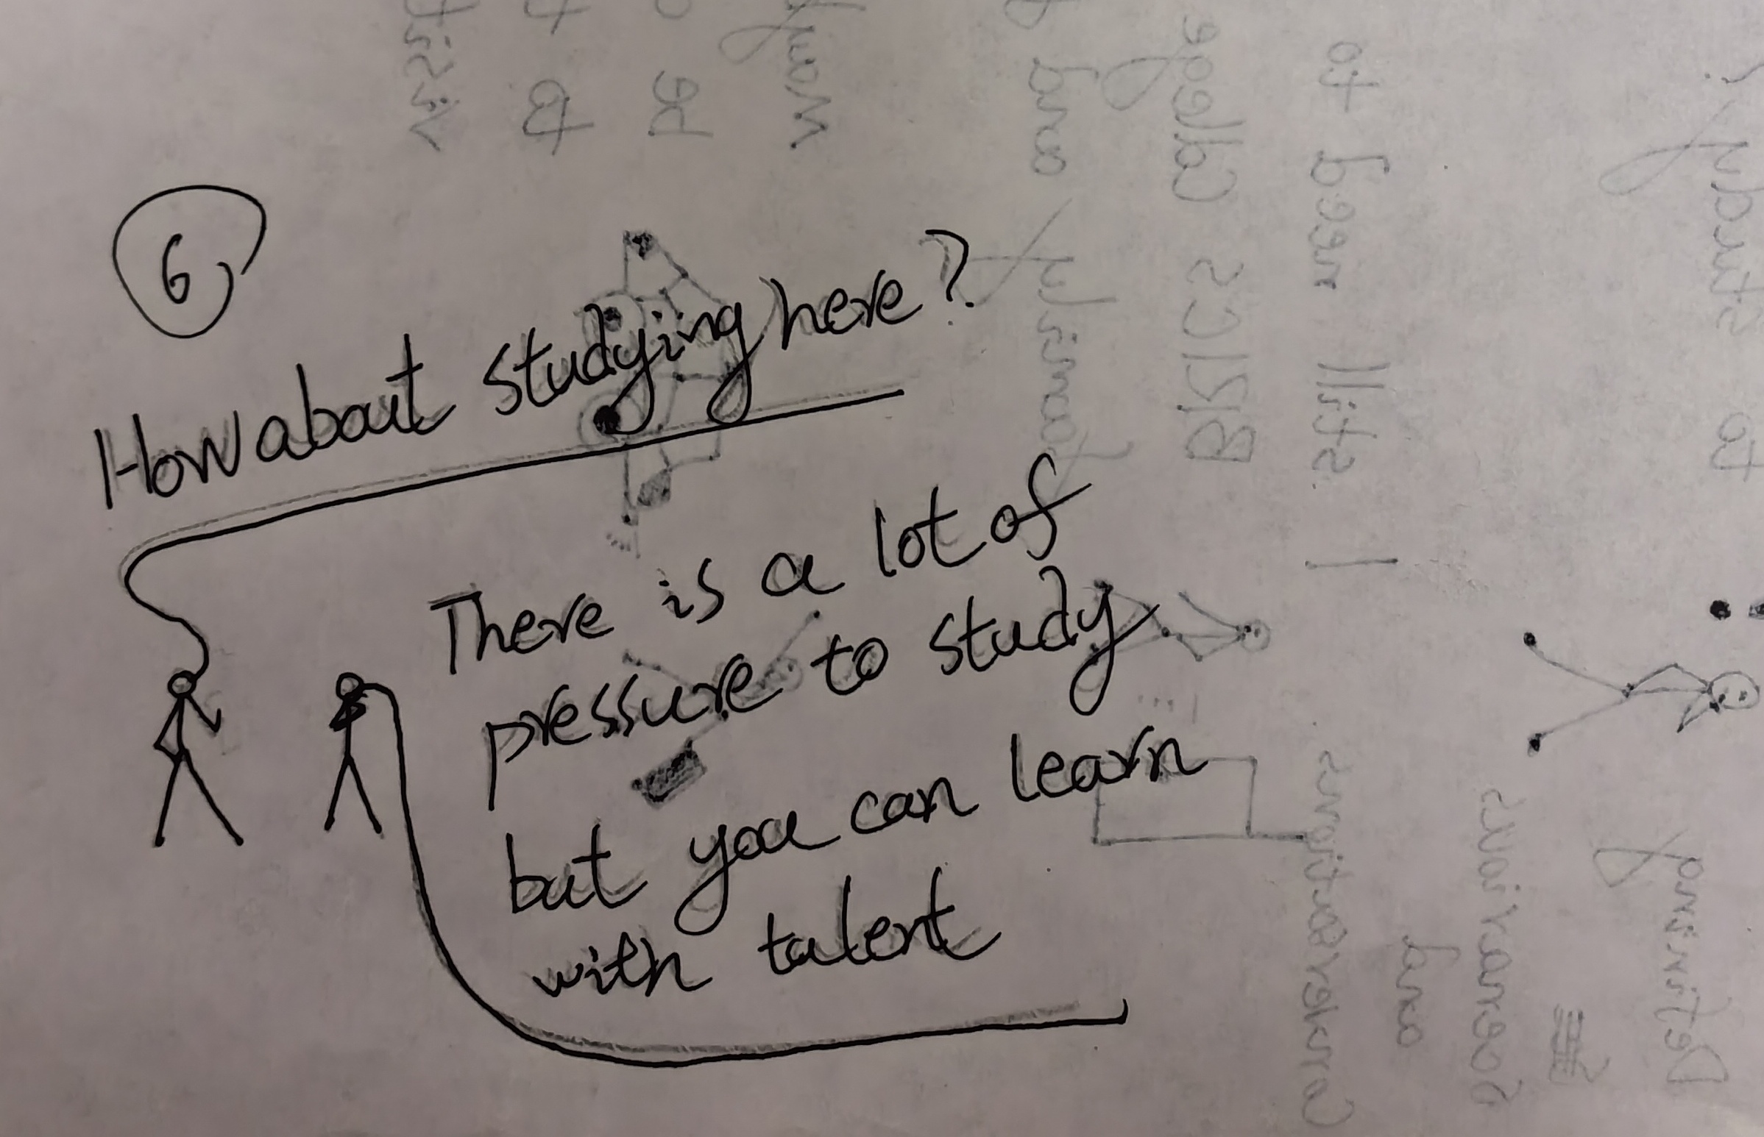

↓

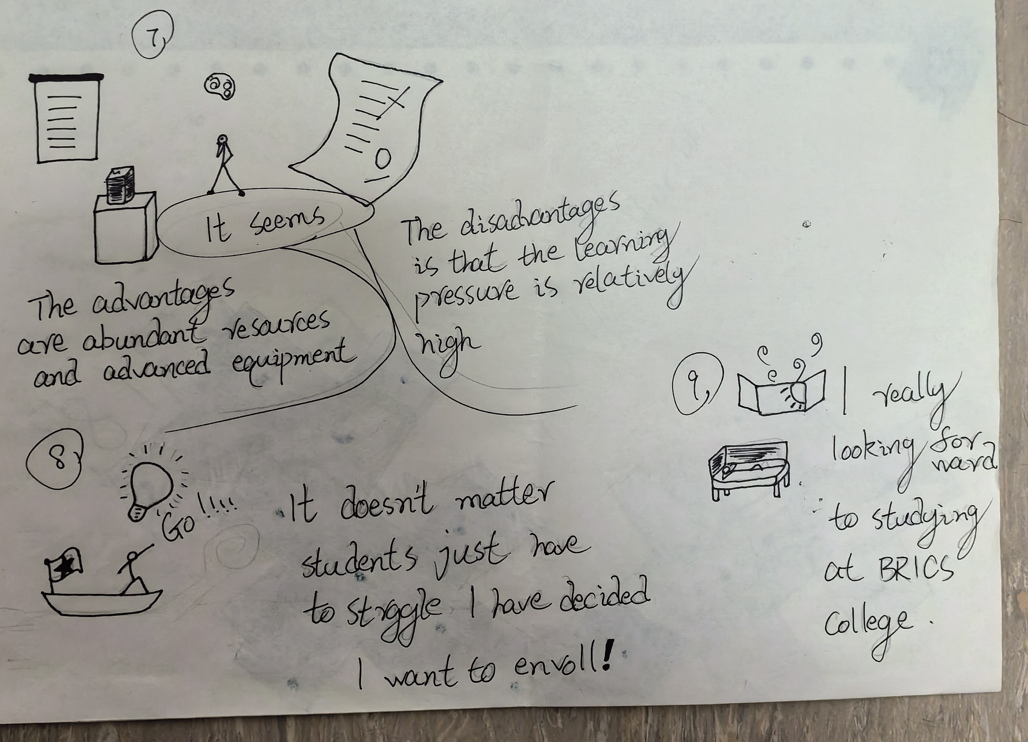

***All parts after improvement***

**Final Delivery**

Make sure the comic fits in A3 paper format.

Compile the progress and final version of all Sprints into one document.

Share the final comic with the class and gather feedback.

**Гэн Чжицзе(Geng Zhijie)**